Los Angeles Conservancy Preservation Awards

2025 Application Information Packet

|  |
| --- |
| Early Bird Period: October 9-November 15, 2024 ($100 application fee)  Application Period: December 13, 2024 ($150 application fee) |

The Los Angeles Conservancy welcomes applications for its 2025 Annual Preservation Awards, honoring outstanding achievements in historic preservation. An independent jury of distinguished architects, preservation professionals, and business and community leaders select award recipients. Awards will be presented at a celebration event in spring 2025.

**Everything in this document is relevant to your application.** Please read it carefully. If you have any questions, please contact us at [advocacy@laconservancy.org.](mailto:advocacy@laconservancy.org.)

Eligibility

The types of projects eligible for a Preservation Award include:

* Construction projects: restoration, rehabilitation, or adaptive reuse of a residential, commercial, or institutional structure
* Preservation plans, programs, policies, or studies
* Interpretive and educational programs in historic preservation (courses, publications, conferences, media, installations, exhibits, etc.)
* Grassroots preservation efforts by an individual or group
* Cultural landscapes (eligible for the Royce Neuschatz Award, established to honor the former Conservancy Board member and advocate for open space in the urban environment)
* Art/media/installation projects that reflect and educate on cultural aspects and historic places

To qualify for a Preservation Award, a project must:

* Demonstrate outstanding achievement in the field of historic preservation
* Be located in Los Angeles County
* Be completed by the date the application is submitted (projects completed before 2024 are eligible, as are previously nominated projects that did not receive an award)
* (For construction projects) Should meet the [Secretary of the Interior’s Standards for the Treatment of Historic Properties](https://www.nps.gov/articles/000/treatment-standards-preservation.htm)
* (For cultural landscape projects) Follow the [Secretary of the Interior’s Guidelines for the Treatment of Cultural Landscapes](https://www.nps.gov/crps/tps/landscape-guidelines/)

**Application Requirements**

Applicants will be asked to provide the following elements as a part of their application.

1. **Project Information**

* Project Type
* Cultural Significance
* Historic/Original Project Name
* Current Project Name
* Project Address
* Project Start and End Dates
* Applicant Contact Information

**Construction projects must also include:**

* + Original Architect and/or Builder
  + Architectural Style
  + Date of Original Completion
  + Landmark Designations

1. **Project Narrative**

A project narrative helps the jury understand the story of the project. The total word count (all sections combined) should be between 1,000 and 2,000 words.

***Significance:*** Present a brief history of the project and its importance to its community and the Los Angeles area before and after its completion. In short, why this project matters.

Construction Projects: Also include the history of the property, structure, and area; general architectural description of the property and the neighborhood or surroundings, the architectural style, original use and other uses, any association with historic people or events; and any historic designations and the date of the designations.

***Project Work:*** Please describe the project’s overall story, including the scope, preservation philosophy, impetus for initiating the project, the goal of the project, the people it served in the past, and who it will serve now and in the future. Your story should also include who were the people involved in making the project happen from start to finish.

Construction Projects: Also describe the use(s) of the structure, specifying restoration, rehabilitation, adaptive reuse, landscape, educational, or other. Please include what if any portions of the property were affected or unaffected by the project and the manner in which compliance with the Secretary of Interior’s Standards was ensured.

***Condition and Challenges:*** Please provide context for the project’s story, including challenges, such as gaining support, funding, or financing; technical issues; development pressures; politics; or other obstacles.

Construction Projects: Include the historic building or structure condition before the project and related challenges.

***Public Benefit:*** Describe the project’s overall impact, such as how it advances historic preservation in Los Angeles County and provides specific benefits to the public after project completion. Highlight how the project is a model for others, illustrating the benefits and possibilities of preservation for similar projects.

**How To Apply**

**The Preservation Awards application form has changed. Applicants can now submit project information and narratives directly on our new form system and upload or provide links to supporting material.**

**\*\*You can save your progress on the form and resume your application later.\*\***

**Step 1: Organize your project information.**

Reference Application Requirements (above) to organize the information you will need to submit as a part of your application.

**Step 2: Collect all the media assets related to your project.**

Add photos, graphics, video, and other media assets related to your project in a digital folder. Copy the folder onto a file-sharing service (Dropbox, Google Drive, etc.) and create a shareable link. You will need this link when you submit the form.

**Photo Files: Must be .JPG or .PNG files and include at least three high-resolution photographs.**

**Video Files: Must be .mp4 or .mov files and in standard 1980×1080 format.**

**\*IMPORTANT: Please use the following naming conventions in labeling the application materials.**

**PHOTOS/VIDEO: (Your Project’s Name)-(Photo Number)**

**HI-RES PHOTO: (Your Project’s Name)-HiRes-(Photo Number)**

**STEP 3: Download templates for your supporting material.**

Download templates for some of the required supporting material. Then, complete them for your project.

* [Project Team Contact Information spreadsheet](https://www.laconservancy.org/wp-content/uploads/2024/10/2025-Project-Team-Contact-Information.xlsx)* (Microsoft Excel)
* [Project Photo Presentation](https://www.laconservancy.org/wp-content/uploads/2024/10/2025-Project-Photo-PPT-Template.pptx)* (16:9 Microsoft PowerPoint)
* [Photo Credits for Project Images and Video](https://www.laconservancy.org/wp-content/uploads/2024/10/2025-Photo-and-Video_Credits-Project_Name-1.xlsx) (Microsoft Excel)

**\*IMPORTANT: Please use the following naming conventions in labeling the application materials.**

**CONTACT LIST: Project Team Contacts_(Your Project’s Name)**

**POWERPOINT: Photo PPT_(Your Project’s Name)**

**Step 4: Review and submit your application and materials.**

Double-check that your information and materials are complete. Congratulations, you’re ready to submit your application at [**laconservancy.org/2025PresAwardsApp**](https://laconservancy.org/2025PresAwardsApp).

|  |
| --- |
| **You are responsible for ensuring that all elements of the application are uploaded to your file-sharing service.** We reserve the right to disqualify any application not received by the deadline, regardless of technical or delivery error. We will refund any fee payments for applications not received in time. |

Images and Video Recordings

|  |
| --- |
| **IMPORTANT: By submitting photos or videos of the project, you grant the Los Angeles Conservancy permission to reprint, publish, and use for distribution these assets in the Preservation Awards Celebration live or recorded program, publicity and publications, such as press releases, program books, newsletters, Los Angeles Conservancy website, social media, and other materials or programs about the Los Angeles Conservancy and/or the Preservation Awards.** |

Please submit:

* **At least 20 photo images or video clips of the project (40 – 50 media assets preferred)**.
* **Slide presentation of project photos (Microsoft PowerPoint)**
  + *Please place individual JPEG or PNG images in a slide presentation;* ***one image per slide and please provide captions*** *below photo when necessary to provide context. Add additional slides to accommodate your photos. Use black background only. Do not include company logos, watermarks, or any other graphics/designs on slide.*
  + *Photos DO NOT need to follow automatic sizing in PowerPoint.*
* **Credits for Photos and Videos (Microsoft Excel)**
  + *In a Microsoft Excel spreadsheet, please submit credit information for photographs and video assets submitted. Please secure permission to use photographs before submitting them.*

**Photos should be JPEG or PNG images in color (except for historic photos). All photos must be high resolution: 150 dpi or greater and either 1920 pixels wide (horizontal) or 1080 pixels wide (vertical):**

* Historic views of the structure, site, area, and/or people involved in the story
* The structure/site/project over the years, showing its evolution
* The site (exterior, interior, detail) before the project began
* The preservation work in progress and the people involved with the project (the workers completing work; for non-construction projects: events, organizing meetings, press clips, etc.)
* The completed project (corresponding to “before” images if possible)
* People at the completed project/using the work completed (people celebrating at reopening event, people at community events, people using the spaces for their intended purpose, etc.)
* Any other images that help tell the story of the project and its positive impact on the community and/or the field of preservation

High-Resolution Images of the Completed Project

In addition, please include:

* 3 – 5 high-resolution (300 dpi) JPEG or PNG color images of the completed project, preferably horizontal
* Credit information for each image in a Microsoft Word document.

Application Tips

Tell a compelling, succinct story.

In addition to recognizing outstanding achievement, the Awards convey the value of historic preservation to a wide audience. Successful applications tell the story of their project in the most compelling way, encompassing:

* The project’s historical context
* Specific goals of the project
* Specific challenges the project team had to overcome
* The project’s benefits to the people in the community
* The broader lessons to be drawn from the project

Use a range of descriptive, high-quality images and video.

**Quality imagery is essential to conveying a project’s importance, challenges, and impact.** Although Conservancy staff members may conduct site visitsfor nominated projects so that we can answer the jury’s questions, jury members themselves typically cannot visit each project nominated for an award. We will contact you separately to arrange site access, if necessary. As a result, **the photos and videos submitted with an application are often the only way the jury can visualize a project.**

**Other qualities** the jury looks for in choosing Preservation Award recipients include:

* **Geographic diversity** – projects throughout Los Angeles County
* **A range of project types** – residential, commercial, institutional structures; landscape projects; planning, grassroots advocacy, media, and educational projects
* **Community diversity** – projects that positively affect the wide range of communities and neighborhoods throughout Los Angeles County

Questions?

Contact Camille Elston at [**celston@laconservancy.org**](mailto:celston@laconservancy.org). Thanks for your interest, and good luck!

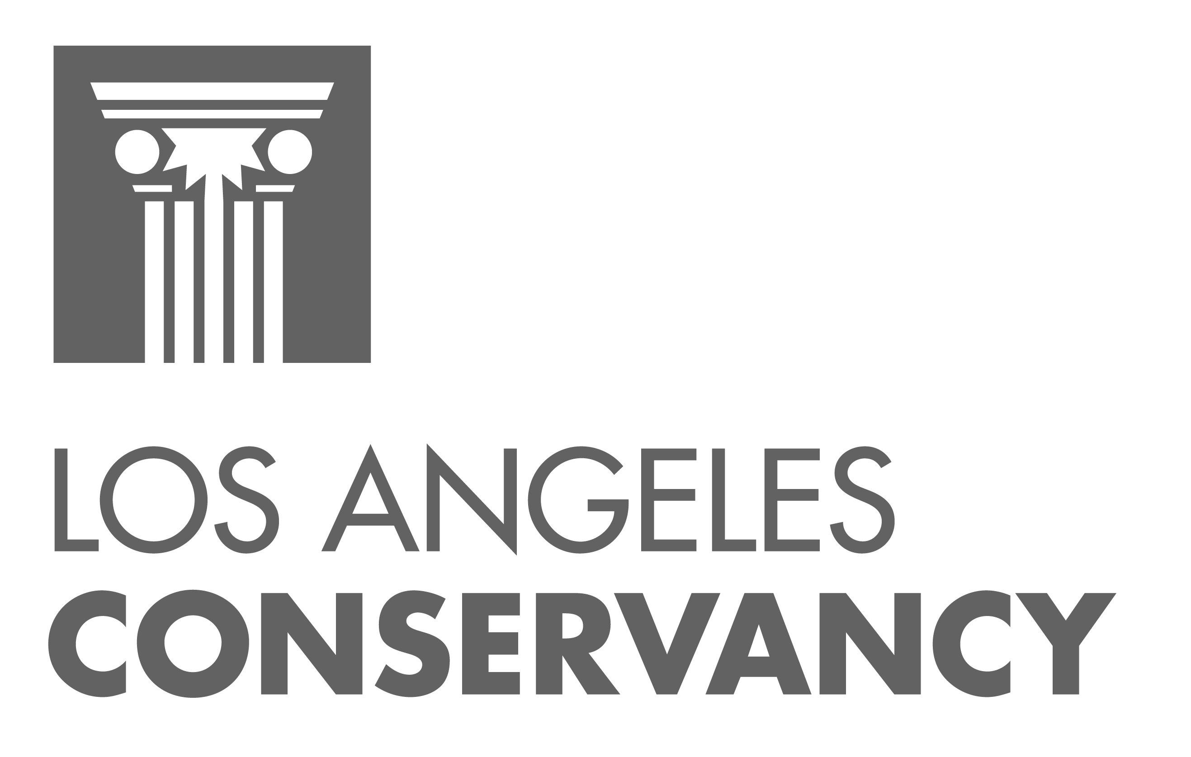

523 W. Sixth St., Suite 826

Los Angeles, CA 90014

(213) 623-2489 | **info@laconservancy.org**

© 2024 Los Angeles Conservancy

The Los Angeles Conservancy is a nonprofit membership organization that works through education and advocacy to recognize, preserve, and revitalize the historic architectural and cultural resources of Los Angeles County. **Learn more or join today at laconservancy.org.**